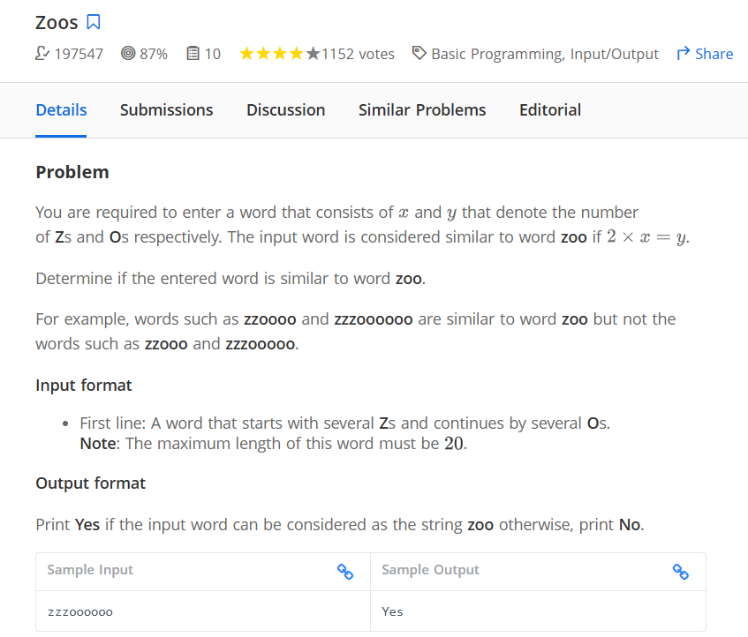
word = input()

#print(word)

first_letter = word[0]
#print(first_letter)

last_letter = word[-1]
#print(last_letter)

first_letter_cnt = 0
last_letter_cnt = 0
for i in word:
if i == first_letter:
first_letter_cnt += 1
elif i == last_letter:
last_letter_cnt += 1
if first_letter_cnt* 2 == last_letter_cnt:
print('Yes')
else:
print('No')

=========================== end

